**SPRING CRUD OPERATIONS**

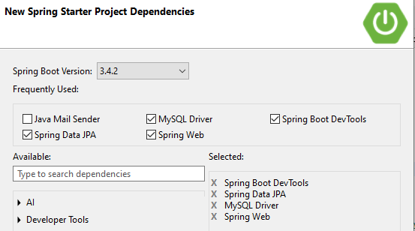

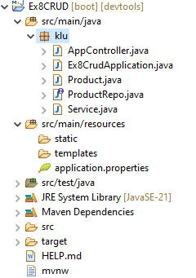

application.properties

---------------------------

spring.application.name=ex8

server.port=8081

spring.datasource.driver-class-name=com.mysql.cj.jdbc.Driver

spring.datasource.url=jdbc:mysql://localhost:3306/FSAD

spring.datasource.username=root

spring.datasource.passowrd=root

spring.jpa.hibernate.ddl-auto=update

spring.jpa.properties.hibernate.dileact=org.hibernate.dialect.MYSQLDileact

spring.jpa.show-sql=true

.......................................................................................................................................................

AppController.java

------------------------

package com.klu;

**import** java.util.List;

**import** org.springframework.beans.factory.annotation.Autowired;

**import** org.springframework.web.bind.annotation.DeleteMapping;

**import** org.springframework.web.bind.annotation.GetMapping;

**import** org.springframework.web.bind.annotation.PathVariable;

**import** org.springframework.web.bind.annotation.PostMapping;

**import** org.springframework.web.bind.annotation.PutMapping;

**import** org.springframework.web.bind.annotation.RequestBody;

**import** org.springframework.web.bind.annotation.RestController;

@RestController

**public** **class** AppController {

@Autowired

Service s;

//http://localhost:8080/product

@PostMapping("/product")

**public** String insertProduct(@RequestBody Product product)

{

**return** s.insertData(product);

}

//http://localhost:8080/product

@PutMapping("/product")

**public** String updateProduct(@RequestBody Product product)

{

**return** s.updateData(product);

}

//http://localhost:8080/product/111

@DeleteMapping("/product/{id}")

**public** String updateProduct(@PathVariable("id") **int** id)

{

**return** s.deleteData(id);

}

//http://localhost:8080/product

@GetMapping("/product")

**public** List<Product> retrieveProduct()

{

**return** s.retrieveData();

}

}

........................................................................................................................................................

Ex8CRUD Application

-------------------------------

package com.klu;

import org.springframework.boot.SpringApplication;

import org.springframework.boot.autoconfigure.SpringBootApplication;

@SpringBootApplication

public class Ex8Application {

public static void main(String[] args) {

SpringApplication.run(Ex8Application.class, args);

System.out.println("CRUD Application has been running...");

}

}

......................................................................................................................................................

Product.java

-----------------------

package com.klu;

import jakarta.persistence.Entity;

import jakarta.persistence.Id;

@Entity

public class Product {

@Id

int id;

String name;

public int getId() {

return id;

}

public void setId(int id) {

this.id = id;

}

public String getName() {

return name;

}

public void setName(String name) {

this.name = name;

}

@Override

public String toString() {

return "Product [id=" + id + ", name=" + name + "]";

}

}

.....................................................................................................................................................

ProductRepo.java

-----------------------------------

package com.klu;

import org.springframework.data.jpa.repository.JpaRepository;

public interface ProductRepo extends JpaRepository<Product, Integer>{

}

...................................................................................................................................................

Service.java

-------------------

**package com.klu;**

**import** java.util.List;

**import** org.springframework.beans.factory.annotation.Autowired;

@org.springframework.stereotype.Service

**public** **class** Service {

@Autowired

ProductRepo repo1;

**public** String insertData(Product product) {

repo1.save(product);

**return** "Insertes Successfully";

}

**public** String updateData(Product product)

{

**if**(repo1.findById(product.getId())!=**null**)

repo1.delete(product);

repo1.save(product);

**return** "Updated successfully";

}

**public** String deleteData(**int** id)

{

repo1.delete(repo1.findById(id).get());

**return** "Deleted successfully";

}

**public** List<Product> retrieveData()

{

**return** repo1.findAll();

}

}

------------------------------------------------------------------------------------------------------

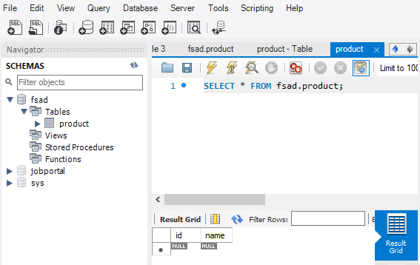

**Insertion operation** :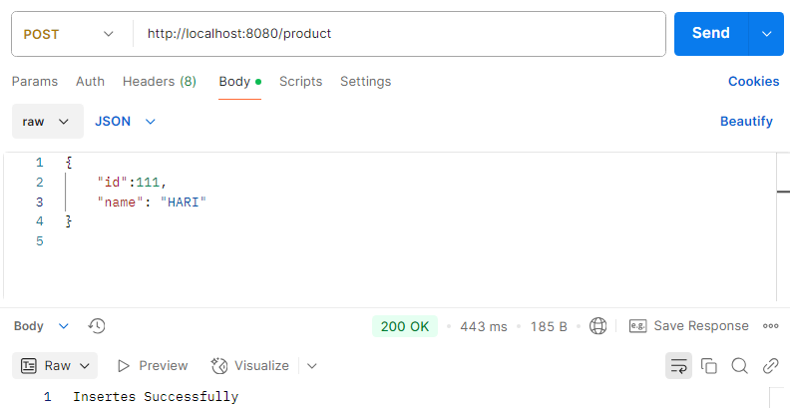

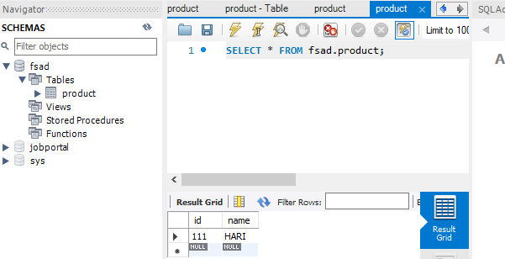

**Updation operation**

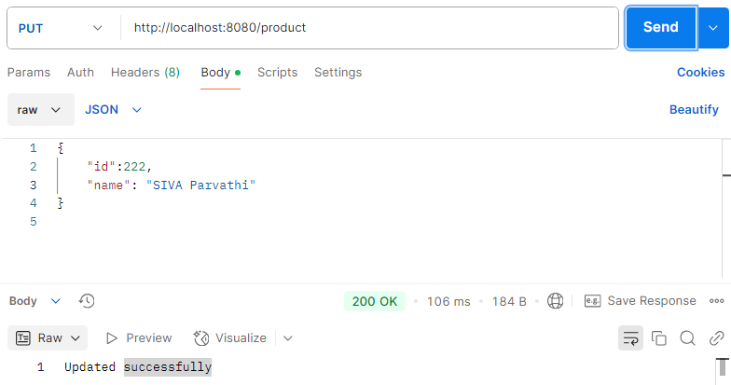

**Retrieval Operaton:**

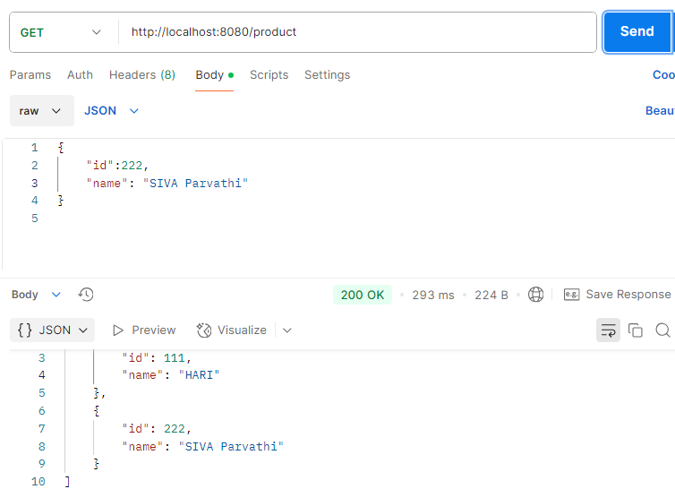

**DELETE Operation:**

